Lab 9
Natnael Kebede
Section 1
- Screen capture showing detected virus details and actions taken by AVG
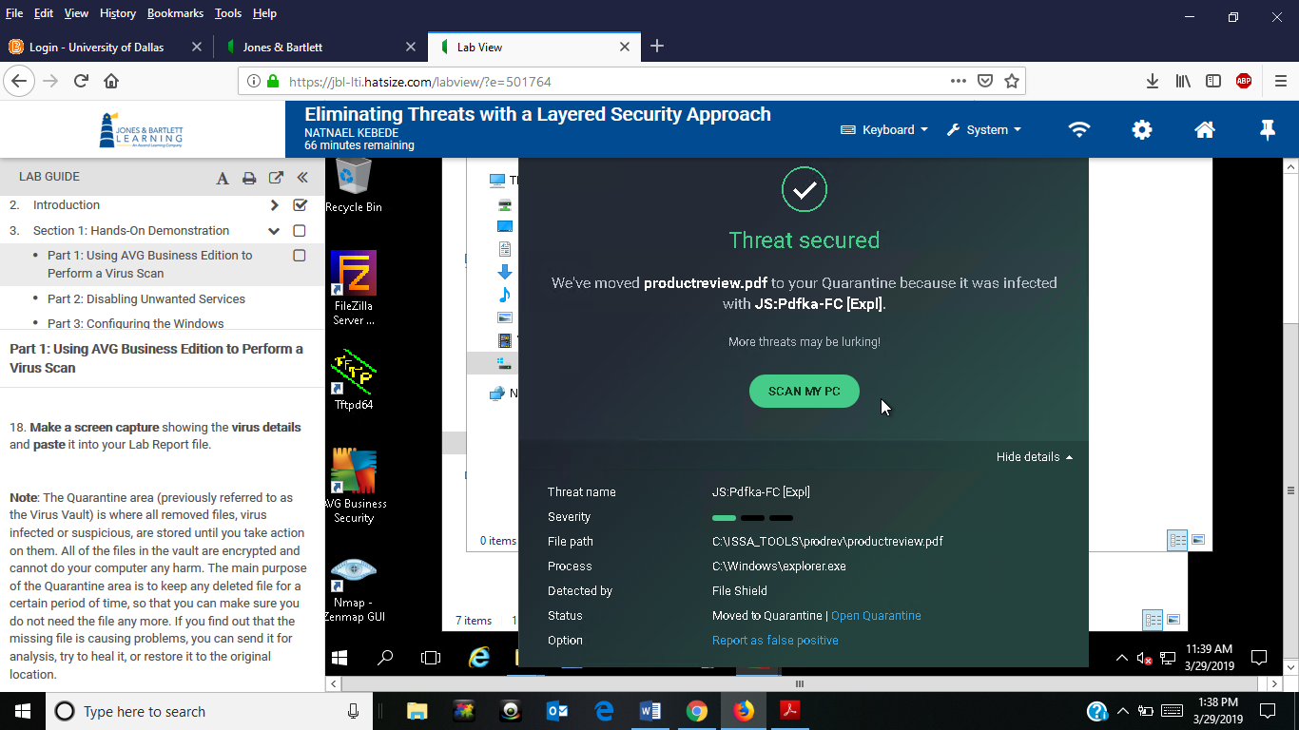
- Screen capture showing emptied Quarantine area (Virus Vault)
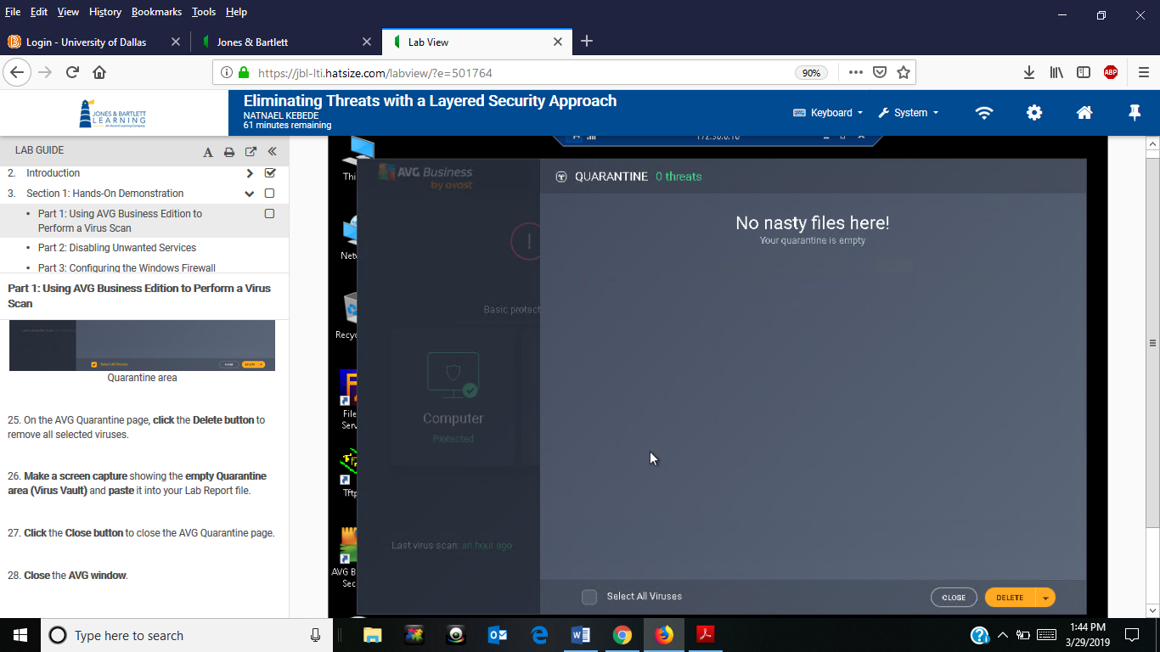
- Screen capture showing the changed startup type in the list of services
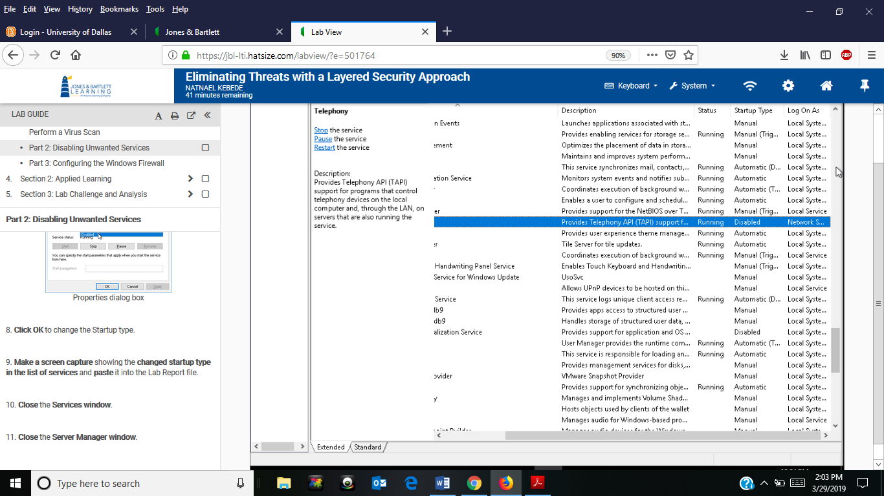
- Screen capture showing updated File and Printer Sharing rule in firewall
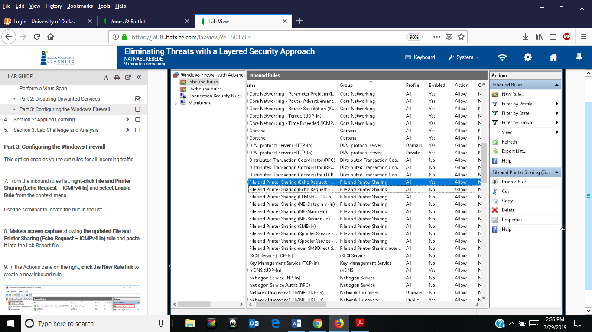

- Screen capture showing the new FileZilla Server rule
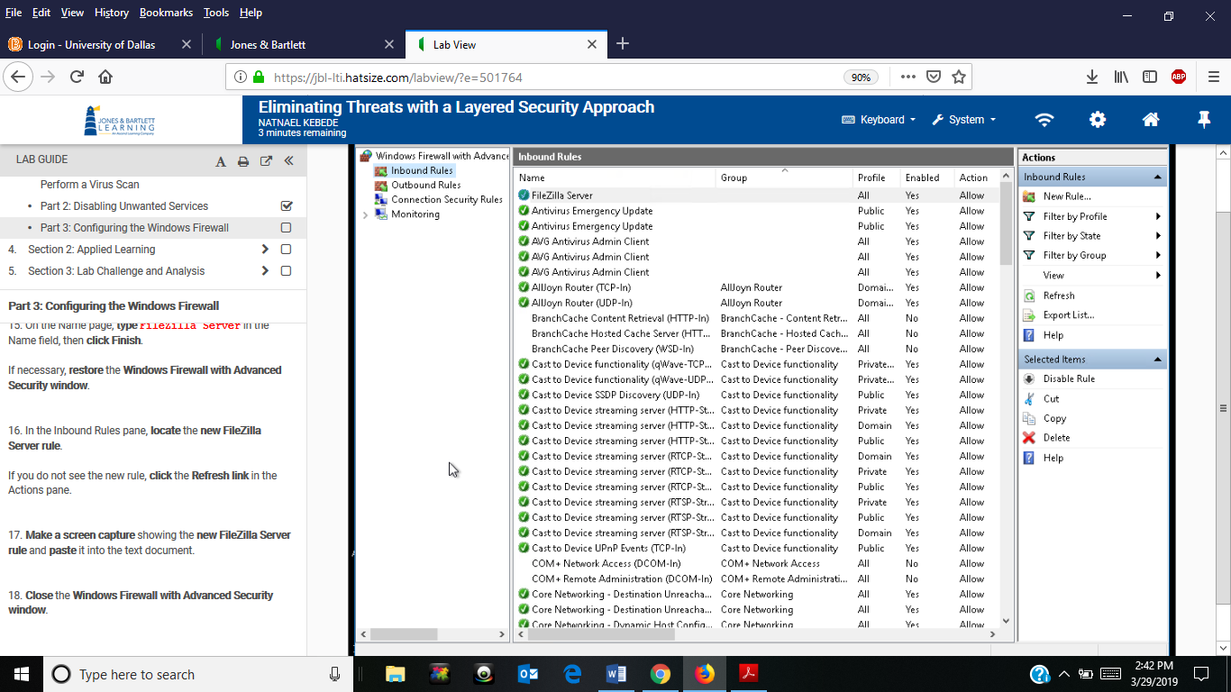
Section 2
- Screen capture showing scan summary (Detection) page
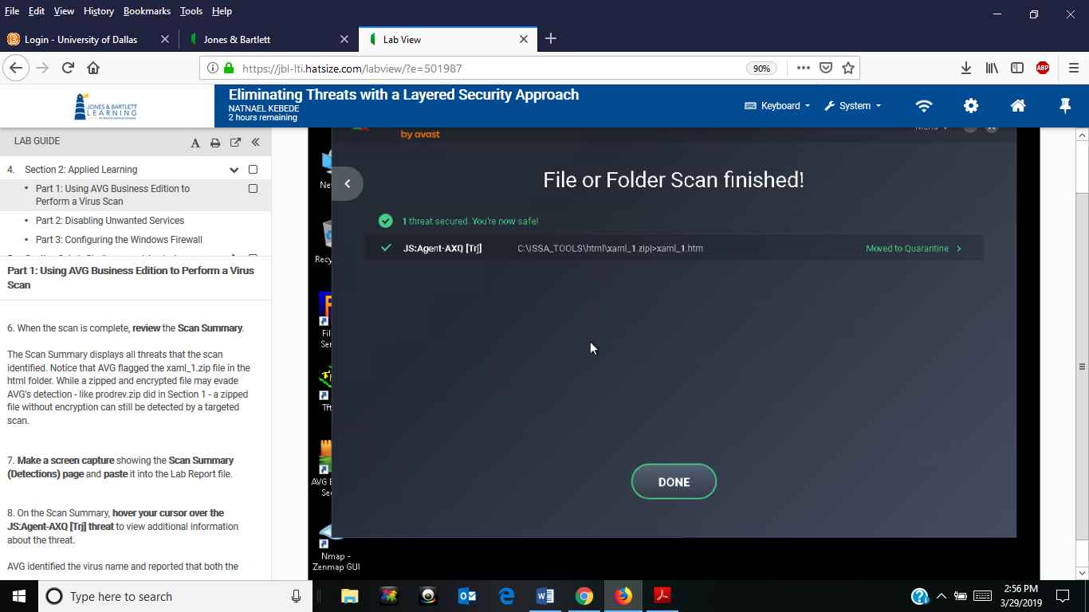

- Screen capture showing Additional threat details
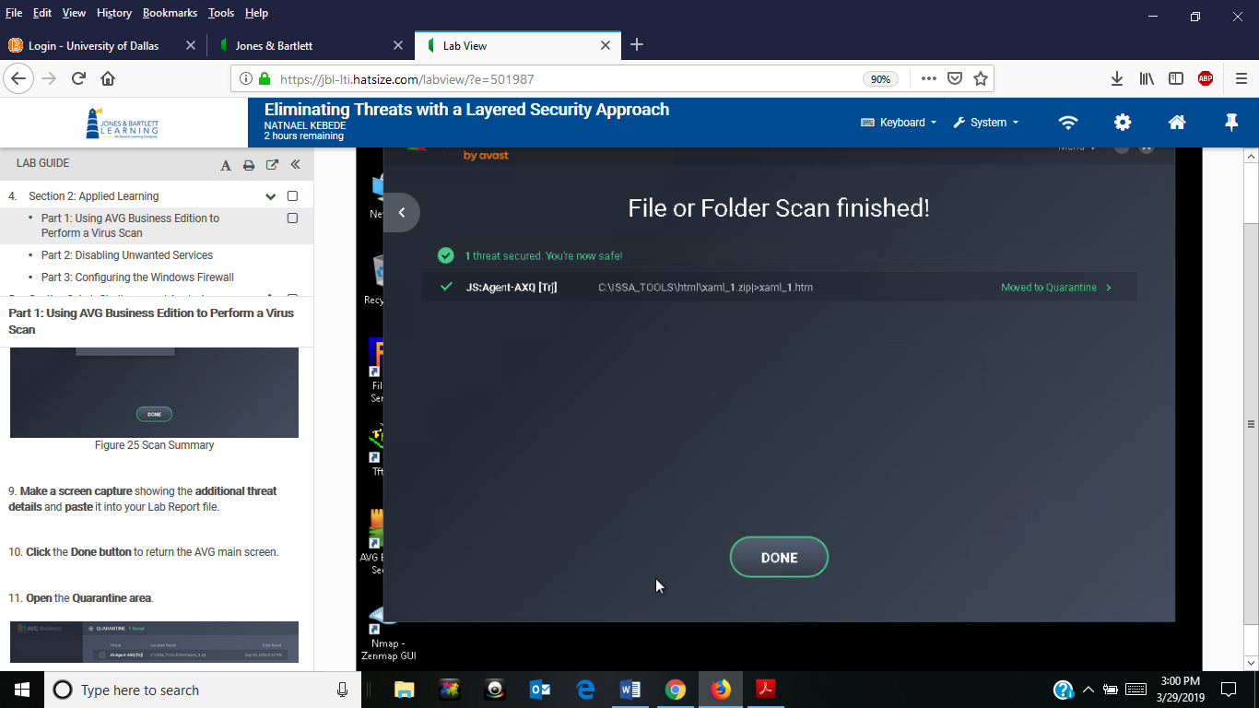
- Screen capture showing emptied Quarantine area (Virus Vault)
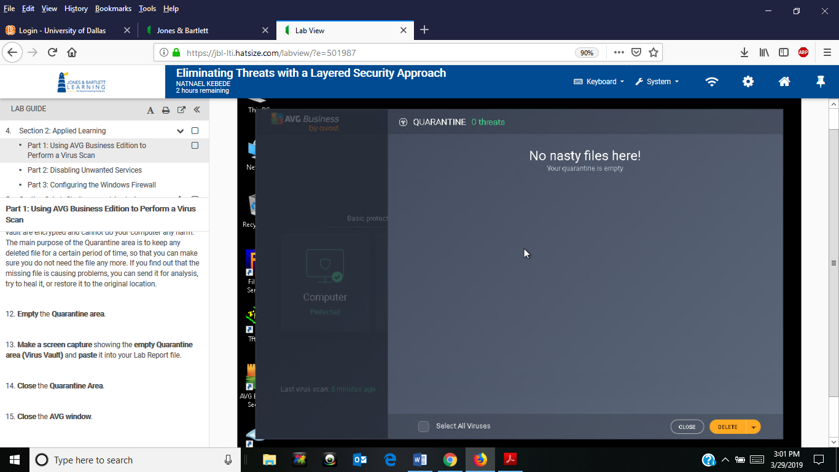

- Screen capture showing updated list of services for Bluetooth Support Service, Print Spooler, and SNMP Trap respectively.
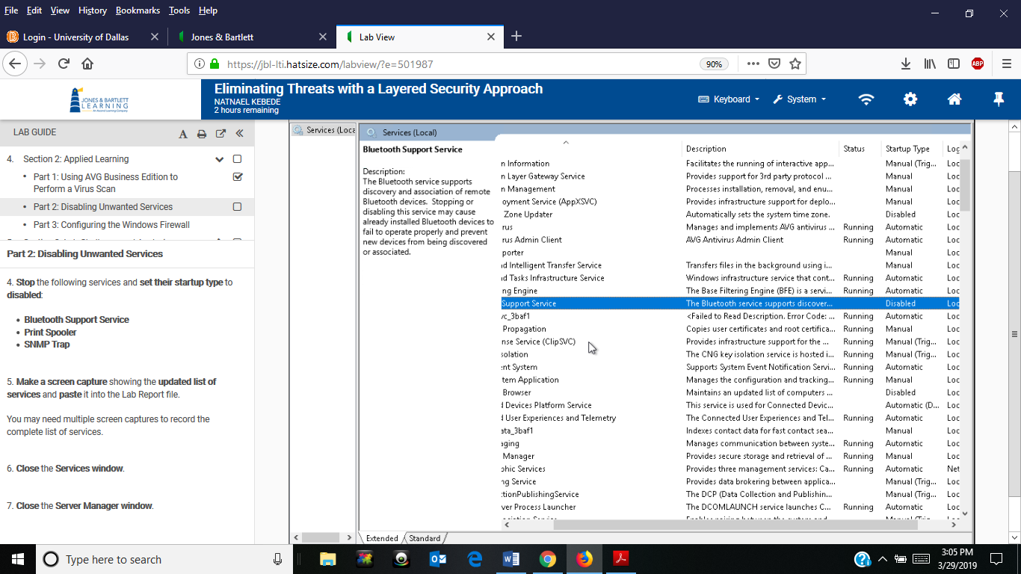
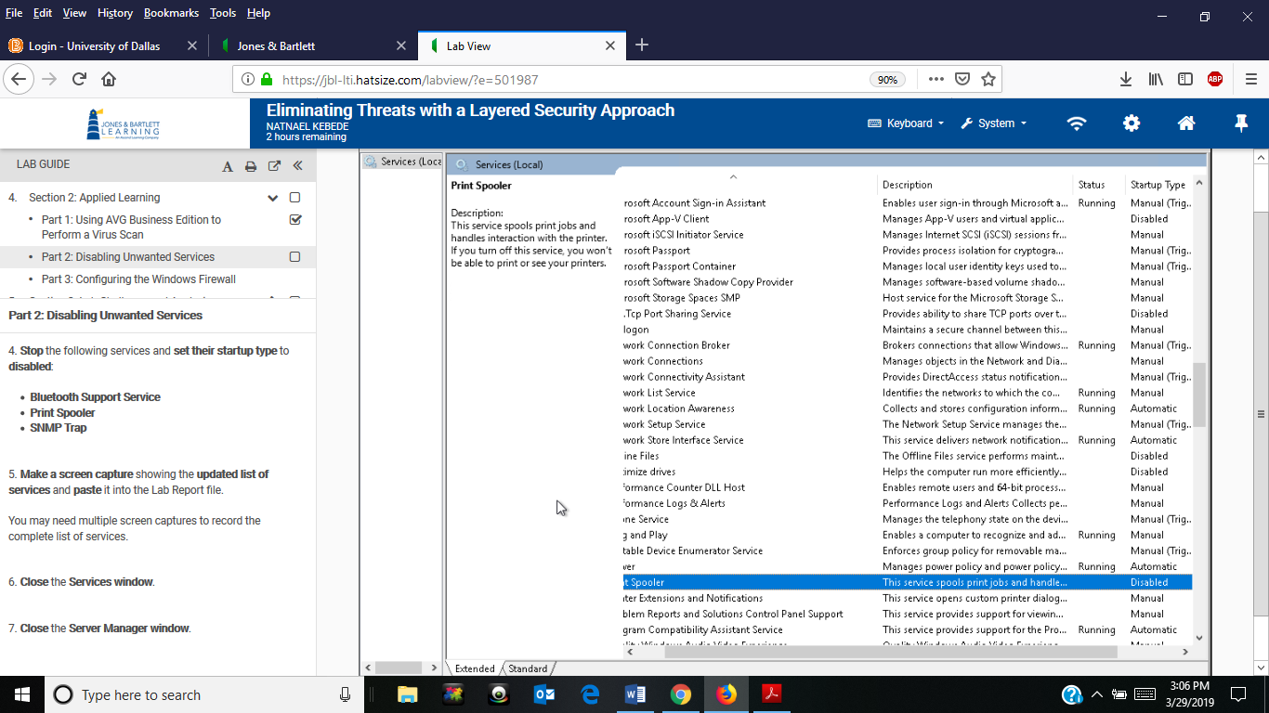
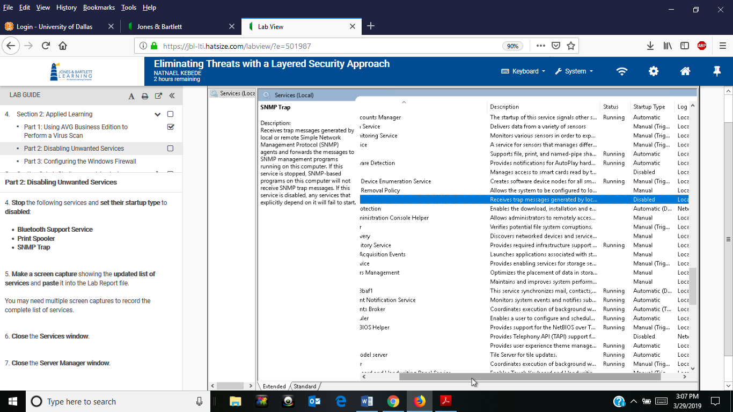
- Screen capture showing updated Email and accounts rule in the firewall
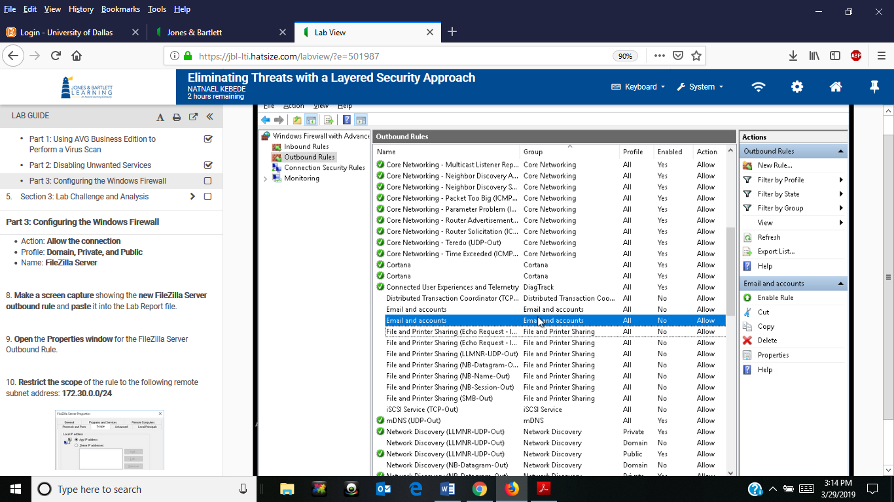
- Screen capture showing the Outbound FileZilla Server outbound rule
